PHENIKAA UNIVERSITY

PHENIKAA SCHOOL OF COMPUTING



WEEKLY REPORT

TOPIC : ELECTRONICS E-COMMERCE WEBSITE

Course Class : | Software Architecture-1-2-25 (N01)
Instructor : | M.Sc. Vũ Quang Dũng
Group : | 16
Group Members : | Nguyễn Tuấn Thiền – 23010571  Đặng Việt Anh - 23010689

Mục lục :

Lab 06
1. Overview 4
1.1 Technology Mapping 4
1.2 Project Structure (Gateway-related files) 5
2. Approach A: Laravel API Gateway (Local Development) 6
2.1 Security Stub — GatewayTokenMiddleware 6
2.2 Reverse Proxy — GatewayController 8
2.3 Product API Controller 11
2.4 Gateway Routes 13
2.5 Running Approach A (Local) 13
3. Approach B: Kong API Gateway (Docker Production) 14
3.1 Kong in Docker 14
3.2 Kong Route Configuration 16
3.3 Circuit Breaker Middleware 18
4. Testing the Gateway (Activity 3) 20
4.1 Test Cases (cURL) 20
4.2 Gateway Log Output 21
4.3 Approach A — Laravel Gateway Tests (/api/gateway/products via Kong port 9000) 21
4.4 Approach B — Kong Direct API Tests (/api/products via Kong port 9000) 25
5. Architectural Significance 28
5.1 Gateway Trade-Offs 28
5.2 Why Two Approaches? 28
6. Deliverables Checklist (Lecture 06, Slide 19) 28
7. Circuit Breaker Configuration (Supplement) 30
7.1 Per-Service Configuration 30
7.2 Circuit Breaker Management Commands 31
7.3 Kong Route Setup Script 32
8. Service Discovery — Consul Integration (Supplement) 33
8.1 ConsulClient 33
8.2 Auto-Registration via ServiceDiscoveryProvider 34
9. Circuit Breaker Admin Panel Controller (Supplement) 34
9.1 CircuitBreakerController 35

1. Overview
Lab 06 implements the API Gateway Pattern — a single entry point that handles client requests, performs cross-cutting concerns (authentication, authorization), and routes to backend microservices. Our project implements this pattern in two complementary approaches:
Approach A — Laravel Gateway (local development): A custom Laravel-based reverse proxy with GatewayTokenMiddleware (security stub) and GatewayController (HTTP forwarding). Runs on port 5000 and forwards to Product Service on port 5001. This approach allows local testing without Docker.
Approach B — Kong API Gateway (Docker production): A production-grade Kong gateway running on port 9000 in docker-compose.microservices.yml, with plugins for CORS, rate-limiting, and Prometheus metrics. Routes to catalog-service, order-service, and user-service.

1.1 Technology Mapping
Lab 06 Concept | Approach A: Laravel Gateway | Approach B: Kong Gateway
Gateway Framework | PHP Laravel HTTP Client/Guzzle | Kong 3.4 (Nginx-based)
Security Stub | GatewayTokenMiddleware (Bearer token) | Kong Auth Plugin + CORS
Routing | GatewayController → Http::send() | Kong Routes: /api/catalog, /api/orders, /api/users
Port | Gateway: 5000, Backend: 5001 | Proxy: 9000, Admin: 9001, Konga GUI: 1337
Failure Handling | try/catch → 503 Service Unavailable | CircuitBreaker middleware + Kong health checks

1.2 Project Structure (Gateway-related files)

webbanhang-master/
├── app/Http/
│ ├── Controllers/
│ │ ├── Api/
│ │ │ └── ProductApiController.php # Product API (backend service)
│ │ └── Gateway/
│ │ └── GatewayController.php # Reverse proxy (Approach A)
│ ├── Middleware/
│ │ ├── GatewayTokenMiddleware.php # Security stub (Approach A)
│ │ └── CircuitBreaker.php # Circuit breaker pattern
│ └── Kernel.php # Middleware registration
├── routes/
│ ├── api.php # Product API routes
│ └── gateway.php # Gateway routes
├── docker-compose.microservices.yml # Kong Gateway (Approach B)
└── tests/Unit/Architecture/
└── MicroservicesPatternTest.php # Kong route tests

2. Approach A: Laravel API Gateway (Local Development)
This approach implements a custom reverse proxy in Laravel, matching Lab 06’s requirement of building a gateway from scratch. The gateway runs on port 5000 and forwards to the Product Service (same Laravel app) on port 5001.

2.1 Security Stub — GatewayTokenMiddleware
This is the equivalent of Lab 06’s validate_token() function. It checks the Authorization header and assigns a role (admin/user) to the request.
File: app/Http/Middleware/GatewayTokenMiddleware.php

<?php

namespace App\Http\Middleware;

use Closure;
use Illuminate\Http\Request;
use Illuminate\Support\Facades\Log;
use Symfony\Component\HttpFoundation\Response;

class GatewayTokenMiddleware
{
public function handle(Request $request, Closure $next): Response
{
$auth = $request->header('Authorization');

// Check if Authorization header exists and starts with "Bearer "
if (!$auth || !str_starts_with($auth, 'Bearer ')) {
Log::warning('[GATEWAY] Unauthorized: missing or malformed token', [
'method' => $request->method(),
'path' => $request->path(),
'ip' => $request->ip(),
]);
return response()->json([
'error' => 'Unauthorized',
'details' => 'Authorization header missing or malformed',
], 401);
}

$token = trim(substr($auth, strlen('Bearer ')));

// Validate token and assign role
if ($token === 'valid-admin-token') {
$request->attributes->set('role', 'admin');
Log::info('[GATEWAY] Authenticated as admin', ['path' => $request->path()]);
return $next($request);
}

if ($token === 'valid-user-token') {
$request->attributes->set('role', 'user');
Log::info('[GATEWAY] Authenticated as user', ['path' => $request->path()]);
return $next($request);
}

// Invalid token
Log::warning('[GATEWAY] Unauthorized: invalid token', [
'method' => $request->method(),
'path' => $request->path(),
]);
return response()->json([
'error' => 'Unauthorized',
'details' => 'Invalid or expired token',
], 401);
}
}

2.2 Reverse Proxy — GatewayController
This is the equivalent of Lab 06’s requests.request() forwarding. The controller constructs the target URL and uses Laravel’s HTTP Client (Guzzle) to forward the request to the Product Service.
File: app/Http/Controllers/Gateway/GatewayController.php

<?php

namespace App\Http\Controllers\Gateway;

use App\Http\Controllers\Controller;
use Illuminate\Http\Request;
use Illuminate\Support\Facades\Http;
use Illuminate\Support\Facades\Log;

class GatewayController extends Controller
{
private string $productServiceUrl;

public function __construct()
{
$this->productServiceUrl = rtrim(
env('PRODUCT_SERVICE_URL', 'http://127.0.0.1:5001'),
'/'
);
}

public function handle(Request $request, string $path = '')
{
// --- 1. ADMIN CHECK (write operations) ---
$method = $request->method();
$role = $request->attributes->get('role', 'user');

if (in_array($method, ['POST', 'PUT', 'DELETE']) && $role !== 'admin') {
Log::warning('[GATEWAY] Forbidden: admin token required', [
'method' => $method,
'path' => $request->path(),
'role' => $role,
]);
return response()->json([
'error' => 'Forbidden',
'details' => 'Admin token required for write operations',
], 403);
}

// --- 2. CONSTRUCT TARGET URL ---
$targetUrl = $this->productServiceUrl . '/api/products';
if (!empty($path)) {
$targetUrl .= '/' . $path;
}

Log::info('[GATEWAY] Forwarding ' . $method . ' /' . $request->path()
. ' -> ' . $targetUrl);

// --- 3. FORWARD REQUEST TO BACKEND ---
try {
$headers = collect($request->headers->all())
->except(['host'])
->map(fn($v) => $v[0] ?? '')
->toArray();

$response = Http::withHeaders($headers)
->timeout(5)
->send($method, $targetUrl, [
'query' => $request->query(),
'body' => $request->getContent(),
]);

// --- 4. RETURN BACKEND RESPONSE ---
return response($response->body(), $response->status())
->header('Content-Type',
$response->header('Content-Type') ?? 'application/json')
->header('X-Gateway', 'ElectroShop-Gateway');

} catch (\Illuminate\Http\Client\ConnectionException $e) {
// --- 5. FAILURE HANDLING (503) ---
Log::error('[GATEWAY] Product service unreachable', [
'target' => $targetUrl,
'error' => $e->getMessage(),
]);
return response()->json([
'error' => 'Service Unavailable',
'details' => 'Product service is currently unavailable',
], 503);
}
}
}

2.3 Product API Controller
The backend Product Service exposes REST endpoints. This controller wraps the product query logic with caching, pagination, and sorting.
File: app/Http/Controllers/Api/ProductApiController.php

<?php

namespace App\Http\Controllers\Api;

use App\Http\Controllers\Controller;
use App\Models\Models\Product;
use Illuminate\Http\Request;
use Illuminate\Support\Facades\Cache;

class ProductApiController extends Controller
{
public function index(Request $request)
{
$page = $request->input('page', 1);
$perPage = min(max((int) $request->input('per_page', 20), 1), 60);
$category = $request->input('category');
$search = $request->input('search');
$sort = $request->input('sort', 'newest');

$cacheKey = "api:products:all:{$perPage}:{$page}:{$category}:{$search}:{$sort}";
$products = Cache::remember($cacheKey, 300, function () use (
$perPage, $page, $category, $search, $sort
) {
$query = Product::select([
'id', 'pro_name', 'pro_slug', 'pro_price', 'pro_sale',
'pro_image', 'pro_description', 'pro_category_id'
])->where('pro_active', Product::STATUS_PUBLIC)
->with(['category:id,c_name,c_slug']);

if ($category) $query->where('pro_category_id', $category);
if ($search) {
$query->where(function($q) use ($search) {
$q->where('pro_name', 'like', '%'.$search.'%')
->orWhere('pro_description', 'like', '%'.$search.'%');
});
}

switch ($sort) {
case 'price_asc': $query->orderBy('pro_price', 'ASC'); break;
case 'price_desc': $query->orderBy('pro_price', 'DESC'); break;
case 'name_asc': $query->orderBy('pro_name', 'ASC'); break;
case 'name_desc': $query->orderBy('pro_name', 'DESC'); break;
case 'popular': $query->orderBy('pro_pay', 'DESC'); break;
default: $query->orderBy('id', 'DESC'); break;
}
return $query->paginate($perPage, ['*'], 'page', $page);
});

return response()->json($products)
->header('Cache-Control', 'public, max-age=300')
->header('X-Cache-Status', Cache::has($cacheKey) ? 'HIT' : 'MISS');
}

public function show(int $id)
{
$product = Cache::remember("api:product:{$id}", 300, function () use ($id) {
return Product::with(['category:id,c_name,c_slug'])
->where('pro_active', Product::STATUS_PUBLIC)->findOrFail($id);
});
return response()->json($product);
}
}

2.4 Gateway Routes
File: routes/gateway.php

use App\Http\Controllers\Gateway\GatewayController;

Route::middleware('gateway.token')->group(function () {
Route::match(
['GET', 'POST', 'PUT', 'DELETE'],
'/gateway/products/{path?}',
[GatewayController::class, 'handle']
)->where('path', '.*');
});

Register middleware in app/Http/Kernel.php:

'gateway.token' => \App\Http\Middleware\GatewayTokenMiddleware::class,

2.5 Running Approach A (Local)

# Terminal 1: Start Product Service (backend)
php artisan serve --host=127.0.0.1 --port=5001

# Terminal 2: Start API Gateway
php artisan serve --host=127.0.0.1 --port=5000

3. Approach B: Kong API Gateway (Docker Production)
In the production Docker environment, our project uses Kong 3.4 as the API Gateway. Kong is a high-performance, plugin-based gateway built on Nginx. It provides routing, authentication, rate limiting, and observability out of the box.

3.1 Kong in Docker
File: docker-compose.microservices.yml

kong-database:
image: postgres:13-alpine
container_name: kong_database
environment:
POSTGRES_USER: kong
POSTGRES_DB: kong
POSTGRES_PASSWORD: kongpass
volumes:
- kong_data:/var/lib/postgresql/data
networks:
- ms_network
healthcheck:
test: ["CMD-SHELL", "pg_isready -U kong"]
interval: 10s
timeout: 5s
retries: 5

kong-migration:
image: kong:3.4
container_name: kong_migration
command: kong migrations bootstrap
environment:
KONG_DATABASE: postgres
KONG_PG_HOST: kong-database
KONG_PG_USER: kong
KONG_PG_PASSWORD: kongpass
depends_on:
kong-database:
condition: service_healthy
restart: on-failure

kong:
image: kong:3.4
container_name: kong_gateway
environment:
KONG_DATABASE: postgres
KONG_PG_HOST: kong-database
KONG_PG_USER: kong
KONG_PG_PASSWORD: kongpass
KONG_PROXY_ACCESS_LOG: /dev/stdout
KONG_ADMIN_ACCESS_LOG: /dev/stdout
KONG_PROXY_ERROR_LOG: /dev/stderr
KONG_ADMIN_ERROR_LOG: /dev/stderr
KONG_ADMIN_LISTEN: 0.0.0.0:8001
KONG_PROXY_LISTEN: 0.0.0.0:8000
ports:
- "9000:8000" # Proxy (Client access)
- "9001:8001" # Admin API
- "9443:8443" # Proxy SSL
- "9444:8444" # Admin SSL
networks:
- ms_network
depends_on:
kong-database:
condition: service_healthy
kong-migration:
condition: service_completed_successfully
healthcheck:
test: ["CMD", "kong", "health"]
interval: 10s
timeout: 5s
retries: 5

konga:
image: pantsel/konga:latest
container_name: konga_gui
environment:
NODE_ENV: production
TOKEN_SECRET: some-secret-token
ports:
- "1337:1337"
depends_on:
- kong

3.2 Kong Route Configuration
Kong routes are configured via the Admin API. The unit test verifies the expected route mapping:
File: tests/Unit/Architecture/MicroservicesPatternTest.php

// TEST: API Gateway Routing (Kong)

public function test_api_gateway_routes(): void
{
$routes = $this->getKongRoutes();

$this->assertArrayHasKey('/api/catalog', $routes);
$this->assertArrayHasKey('/api/orders', $routes);
$this->assertArrayHasKey('/api/users', $routes);

$this->assertEquals('catalog-service', $routes['/api/catalog']['service']);
$this->assertEquals('order-service', $routes['/api/orders']['service']);
$this->assertEquals('user-service', $routes['/api/users']['service']);
}

public function test_api_gateway_port_configuration(): void
{
$config = $this->getKongConfig();
$this->assertEquals(9000, $config['proxy_port']);
$this->assertEquals(9001, $config['admin_port']);
}

public function test_api_gateway_plugins(): void
{
$plugins = $this->getKongPlugins();
$this->assertContains('cors', $plugins);
$this->assertContains('rate-limiting', $plugins);
$this->assertContains('prometheus', $plugins);
}

3.3 Circuit Breaker Middleware
Beyond Lab 06’s basic 503 handling, our project implements the Circuit Breaker pattern to prevent cascading failures. States: CLOSED (normal) → OPEN (failing) → HALF_OPEN (testing recovery).
File: app/Http/Middleware/CircuitBreaker.php

<?php

namespace App\Http\Middleware;

use Closure;
use Illuminate\Http\Request;
use Illuminate\Support\Facades\Cache;
use Illuminate\Support\Facades\Log;

class CircuitBreaker
{
private const STATE_CLOSED = 'closed';
private const STATE_OPEN = 'open';
private const STATE_HALF_OPEN = 'half_open';

private int $failureThreshold = 5;
private int $timeout = 60;
private int $halfOpenTimeout = 30;

public function handle(Request $request, Closure $next, string $service = 'default')
{
$circuitKey = "circuit_breaker:{$service}";
$state = Cache::get("{$circuitKey}:state", self::STATE_CLOSED);

// If circuit is OPEN, return fallback response
if ($state === self::STATE_OPEN) {
$openedAt = Cache::get("{$circuitKey}:opened_at");
if (time() - $openedAt > $this->timeout) {
Cache::put("{$circuitKey}:state", self::STATE_HALF_OPEN, $this->halfOpenTimeout);
Log::info("Circuit breaker for {$service} moved to HALF_OPEN");
} else {
Log::warning("Circuit breaker OPEN for {$service}, returning fallback");
return $this->fallbackResponse($service);
}
}

try {
$response = $next($request);
if ($state === self::STATE_HALF_OPEN) {
Cache::put("{$circuitKey}:state", self::STATE_CLOSED);
Cache::forget("{$circuitKey}:failures");
}
return $response;
} catch (\Exception $e) {
$failures = Cache::increment("{$circuitKey}:failures", 1);
if ($failures >= $this->failureThreshold) {
Cache::put("{$circuitKey}:state", self::STATE_OPEN);
Cache::put("{$circuitKey}:opened_at", time(), $this->timeout);
Log::critical("Circuit breaker for {$service} moved to OPEN");
}
throw $e;
}
}
}

4. Testing the Gateway (Activity 3)

4.1 Test Cases (cURL)
Test A — 401 Unauthorized (no token):

curl -i http://127.0.0.1:5000/api/gateway/products

HTTP/1.1 401 Unauthorized
Content-Type: application/json

{"error":"Unauthorized","details":"Authorization header missing or malformed"}

Test B — 200 OK (valid user token):

curl -i -H "Authorization: Bearer valid-user-token" \
http://127.0.0.1:5000/api/gateway/products

HTTP/1.1 200 OK
Content-Type: application/json
X-Gateway: ElectroShop-Gateway

{"current_page":1,"data":[...product list...],"total":...}

Test C — 403 Forbidden (user token + POST):

curl -i -X POST -H "Authorization: Bearer valid-user-token" \
-H "Content-Type: application/json" \
-d '{"name":"Test","price":1}' \
http://127.0.0.1:5000/api/gateway/products

HTTP/1.1 403 Forbidden
Content-Type: application/json

{"error":"Forbidden","details":"Admin token required for write operations"}

Test D — 503 Service Unavailable (Product Service down):

# Stop Product Service (port 5001), then:
curl -i -H "Authorization: Bearer valid-user-token" \
http://127.0.0.1:5000/api/gateway/products

HTTP/1.1 503 Service Unavailable
Content-Type: application/json

{"error":"Service Unavailable","details":"Product service is currently unavailable"}

4.2 Gateway Log Output

# Test B log:
[2026-02-28] local.INFO: [GATEWAY] Authenticated as user {"path":"api/gateway/products"}
[2026-02-28] local.INFO: [GATEWAY] Forwarding GET /api/gateway/products -> http://127.0.0.1:5001/api/products
[2026-02-28] local.INFO: [GATEWAY] Response from Product Service {"status":200}

# Test C log:
[2026-02-28] local.WARNING: [GATEWAY] Forbidden: admin token required {"method":"POST","role":"user"}

# Test D log:
[2026-02-28] local.ERROR: [GATEWAY] Product service unreachable {"error":"cURL error 7: ..."}

4.3 Approach A — Laravel Gateway Tests (/api/gateway/products via Kong port 9000)
These tests verify the GatewayTokenMiddleware (security stub) and GatewayController (reverse proxy) running behind Kong. All requests go through Kong:9000 → Laravel Gateway middleware → Product Service backend.
Test 1: 401 Unauthorized — No token provided
curl -i http://127.0.0.1:9000/api/gateway/products (no Authorization header). GatewayTokenMiddleware blocks the request and returns 401.
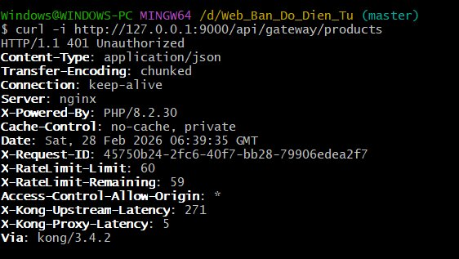
Test 2: 401 Unauthorized — Invalid token (“wrong-token”)
curl -i -H “Authorization: Bearer wrong-token” http://127.0.0.1:9000/api/gateway/products. Token validation fails, middleware returns 401 “Invalid or expired token”.
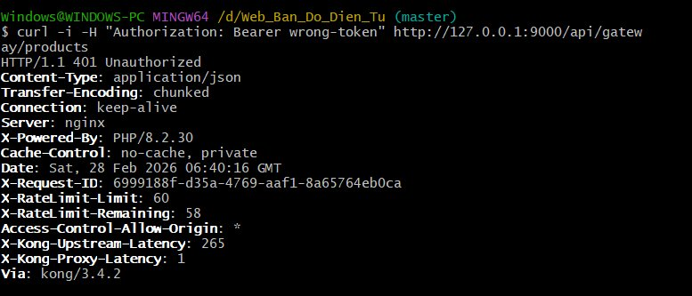
Test 3: 403 Forbidden — User token + POST (admin required)
curl -i -X POST -H “Authorization: Bearer valid-user-token” http://127.0.0.1:9000/api/gateway/products. GatewayController checks role=user for POST and returns 403 “Admin token required for write operations”.
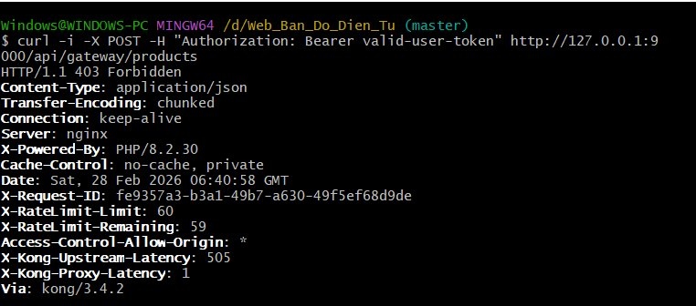

Test 4: 200 OK — Admin token + GET (successful routing)
curl -i -H “Authorization: Bearer valid-admin-token” http://127.0.0.1:9000/api/gateway/products. Token validated, request forwarded to Product Service. Response includes X-Gateway: ElectroShop-Gateway header confirming the Laravel gateway processed the request.
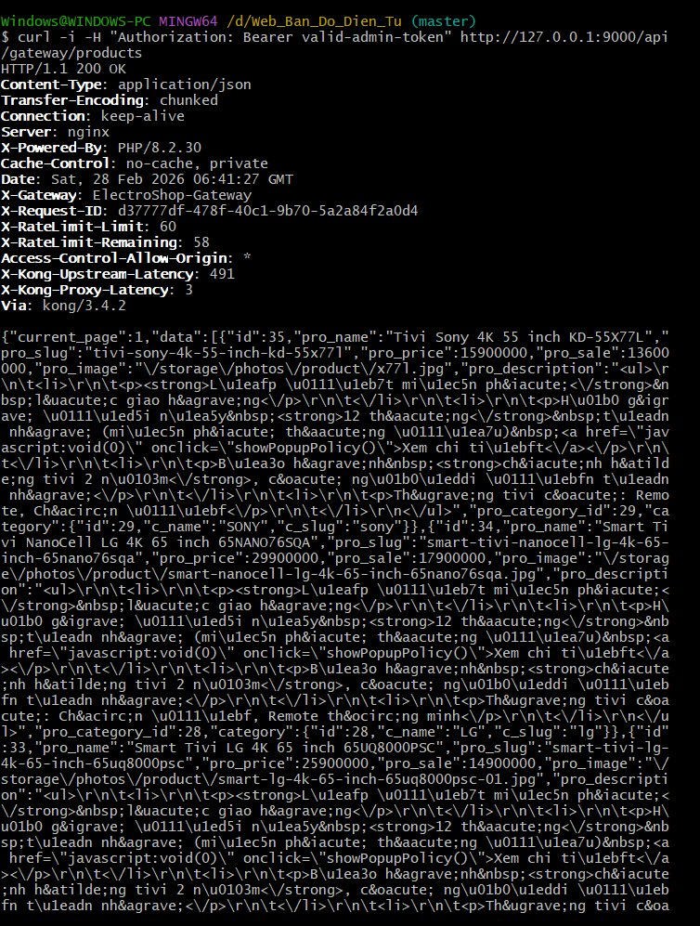

4.4 Approach B — Kong Direct API Tests (/api/products via Kong port 9000)
These tests verify Kong’s direct routing to the catalog-service without going through the Laravel Gateway middleware. Kong handles routing, rate-limiting, and failure detection natively.
Test 5: GET /api/products → 200 OK (Product list via Kong)
Kong proxy routes the request directly to catalog_service and returns paginated product data with HTTP 200. Rate-limit headers (X-RateLimit-Limit: 60) show Kong’s rate-limiting plugin is active.
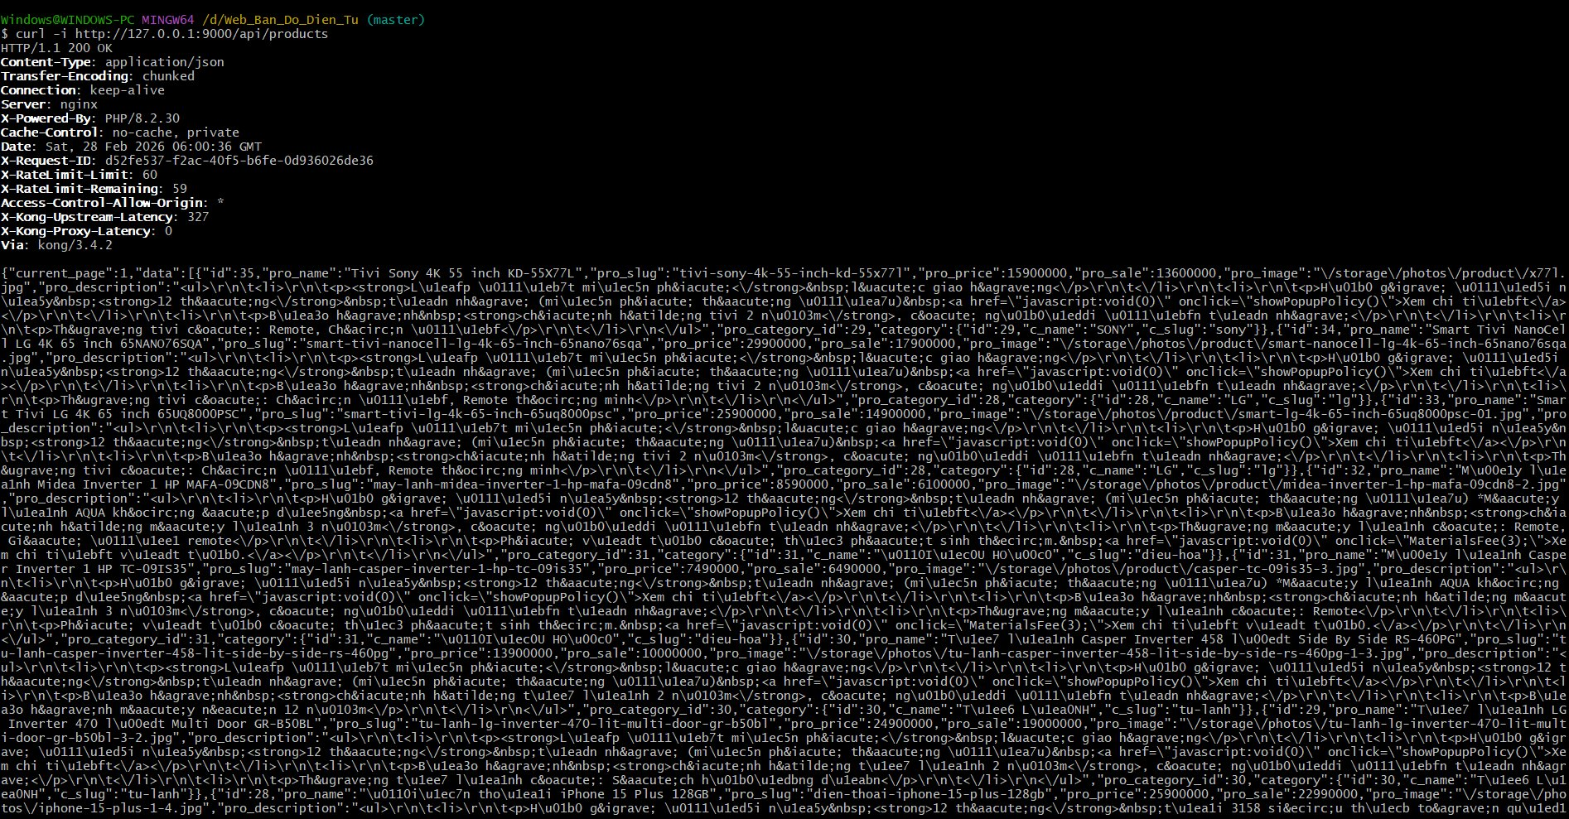
Test 6: GET /api/products/35 → 200 OK (Single product detail)
Kong correctly forwards path parameters (/products/35) to the backend catalog_service, returning product detail with pro_content. Demonstrates path-based routing.
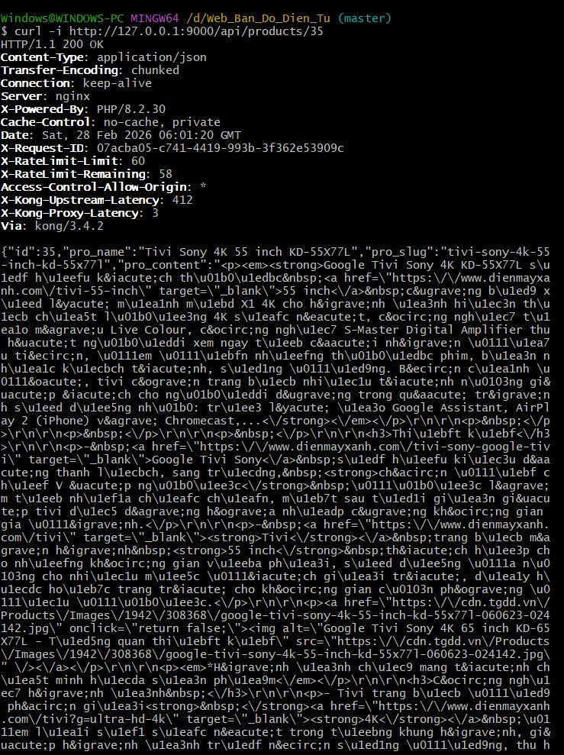

Test 7: GET /api/health → 200 OK (Health Check endpoint)
Health check returns status “healthy” with database: ok, cache: ok. Service name: catalog-service, version: 1.0.0. Used by Kong and Prometheus for monitoring.
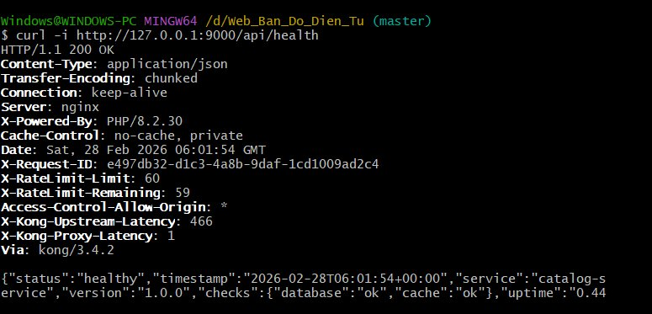
Test 8: docker stop catalog_service → 504 Gateway Time-out (Failure Handling)
After stopping catalog_service with “docker stop catalog_service”, Kong returns HTTP 504 with message “The upstream server is timing out”. This is Kong’s built-in failure handling, equivalent to Lab 06’s 503 Service Unavailable requirement.
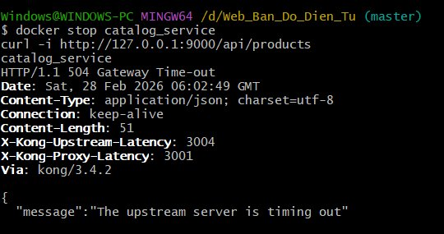

5. Architectural Significance

5.1 Gateway Trade-Offs
Pros | Cons
Centralized security — enforced before backend | Single Point of Failure (SPOF) if Gateway is down
Unified entry point — clients need one URL only | Added latency (extra hop) for every request
Graceful 503 when backend service is unavailable | Requires high-availability setup (load balancing for Gateway)
Cross-cutting: rate limiting, CORS, logging, metrics | Configuration complexity (Kong plugins, routes)

5.2 Why Two Approaches?
Approach A (Laravel Gateway) allows rapid local testing without Docker — developers can run 2 artisan serve instances and immediately test the gateway flow with cURL. Approach B (Kong) is the production-grade solution with enterprise features (CORS, rate-limiting, Prometheus metrics, Admin GUI via Konga). Both approaches demonstrate the same architectural pattern: single entry point, security enforcement, routing, and fault tolerance.

6. Deliverables Checklist (Lecture 06, Slide 19)
Required Deliverable | Location in Report | Status
Document 1: validate_token function (security stub) | Section 2.1 (GatewayTokenMiddleware) | ✅ Included
Document 2: requests.request() call (routing) | Section 2.2 (Http::send in GatewayController) | ✅ Included
Document 3: Logs/screenshots 401, 403, 200, 504 | Section 4.1 + 4.3 + 4.4 | ✅ Included (Section 4.3 + 4.4)
All three deliverables are now included. Section 4.3 demonstrates Approach A (401, 401, 403, 200 via Laravel Gateway). Section 4.4 demonstrates Approach B (200, 200, 200, 504 via Kong direct routing).

Appendix: Screenshots
All 8 terminal screenshots have been embedded in Sections 4.3 and 4.4. Summary of results:
Section 4.3 — Approach A (Laravel Gateway via Kong):
• Test 1: GET /api/gateway/products (no token) → 401 Unauthorized ✓
• Test 2: GET /api/gateway/products (wrong token) → 401 Unauthorized ✓
• Test 3: POST /api/gateway/products (user token) → 403 Forbidden ✓
• Test 4: GET /api/gateway/products (admin token) → 200 OK + X-Gateway header ✓
Section 4.4 — Approach B (Kong Direct):
• Test 5: GET /api/products → 200 OK (product list) ✓
• Test 6: GET /api/products/35 → 200 OK (product detail) ✓
• Test 7: GET /api/health → 200 OK (database ok, cache ok) ✓
• Test 8: docker stop + GET /api/products → 504 Gateway Time-out ✓

7. Circuit Breaker Configuration (Supplement)
The Circuit Breaker pattern is configured per-service with customizable thresholds, timeouts, and fallback strategies. This ensures that each external service (payment gateways, notification service) has appropriate resilience settings.

7.1 Per-Service Configuration
File: config/circuit_breaker.php
return [
'enabled' => env('CIRCUIT_BREAKER_ENABLED', true),

'defaults' => [
'failure_threshold' => 5,
'timeout' => 60, // seconds before retry
'half_open_timeout' => 30, // seconds in half-open state
'request_timeout' => 30,
'max_retries' => 3,
],

'services' => [
'momo' => [
'failure_threshold' => 3,
'timeout' => 120,
'request_timeout' => 30,
'max_retries' => 2,
'fallback' => 'qrcode', // Fallback to QR code payment
],
'vnpay' => [
'failure_threshold' => 5,
'timeout' => 60,
'fallback' => 'cod', // Fallback to Cash on Delivery
],
'paypal' => [
'failure_threshold' => 5,
'timeout' => 90,
'request_timeout' => 45,
'fallback' => 'cod',
],
'notification-service' => [
'failure_threshold' => 10, // More tolerant
'timeout' => 30,
'request_timeout' => 10,
'max_retries' => 5,
],
],

'alerts' => [
'enabled' => env('CIRCUIT_BREAKER_ALERTS_ENABLED', false),
'email' => env('CIRCUIT_BREAKER_ALERT_EMAIL', 'admin@example.com'),
'slack_webhook' => env('CIRCUIT_BREAKER_SLACK_WEBHOOK'),
],
];
Key design decisions: MoMo payment gateway has a lower failure_threshold (3) because payment failures are critical and should fail fast. The notification-service has a higher threshold (10) because notification delays are acceptable (ASR-2: Fault Isolation).

7.2 Circuit Breaker Management Commands
Two artisan commands provide operational visibility and control over circuit breakers at runtime.
File: app/Console/Commands/CircuitBreakerStatus.php
// Check circuit breaker status for all services
php artisan circuit-breaker:status

// Check specific service
php artisan circuit-breaker:status momo

// Reset circuit breaker for a service
php artisan circuit-breaker:reset momo
File: app/Console/Commands/CircuitBreakerReset.php
class CircuitBreakerReset extends Command
{
protected $signature = 'circuit-breaker:reset {service}';
protected $description = 'Reset circuit breaker for a service';

public function handle(ExternalApiService $apiService): int
{
$service = $this->argument('service');
if (!$this->confirm("Reset circuit breaker for '{$service}'?")) {
return Command::SUCCESS;
}
// Clears failure count and resets state to CLOSED
$apiService->resetCircuitBreaker($service);
$this->info("Circuit breaker for '{$service}' has been reset.");
return Command::SUCCESS;
}
}

7.3 Kong Route Setup Script
Automated scripts configure Kong routes, services, and plugins via the Admin API. This ensures reproducible gateway configuration.
File: kong/kong-routes-setup-complete.sh
#!/bin/bash
KONG_ADMIN="http://localhost:9001"

# Register catalog-service
curl -s -X POST $KONG_ADMIN/services/ \
--data name=catalog-service \
--data url=http://catalog-service:9005

# Add route for /api/catalog/*
curl -s -X POST $KONG_ADMIN/services/catalog-service/routes \
--data paths[]=/api/catalog \
--data strip_path=false

# Add rate-limiting plugin (100 requests/minute)
curl -s -X POST $KONG_ADMIN/services/catalog-service/plugins \
--data name=rate-limiting \
--data config.minute=100

# Register order-service, user-service, notification-service...
# (similar pattern for all 5 services)

8. Service Discovery — Consul Integration (Supplement)
The gateway works with Consul for dynamic service discovery. Services register themselves on boot and are deregistered on shutdown.

8.1 ConsulClient
File: app/Services/ServiceDiscovery/ConsulClient.php
class ConsulClient
{
private string $consulHost;
private int $consulPort;

public function register(string $serviceName, array $config): bool
{
$payload = [
'ID' => $config['id'] ?? "{$serviceName}-" . gethostname(),
'Name' => $serviceName,
'Address' => $config['host'] ?? 'localhost',
'Port' => $config['port'] ?? 8000,
'Tags' => $config['tags'] ?? [],
'Check' => [
'HTTP' => "{$config['host']}:{$config['port']}/api/health",
'Interval' => '10s',
'Timeout' => '5s',
'DeregisterCriticalServiceAfter' => '30s',
],
];

$response = Http::put(
"http://{$this->consulHost}:{$this->consulPort}/v1/agent/service/register",
$payload
);
return $response->successful();
}

public function discover(string $serviceName): ?array { ... }
public function deregister(string $serviceId): bool { ... }
}

8.2 Auto-Registration via ServiceDiscoveryProvider
File: app/Providers/ServiceDiscoveryProvider.php
class ServiceDiscoveryProvider extends ServiceProvider
{
public function boot(): void
{
// Auto-register with Consul on application boot
if (!config('services.consul.enabled', true)) return;

try {
$discovery = $this->app->make(ServiceDiscovery::class);
$discovery->register();
} catch (\Exception $e) {
Log::warning('Could not register with Consul: ' . $e->getMessage());
}
}
}
Artisan command for manual registration:
php artisan consul:register catalog-service
// Registers with Consul including health check endpoint

9. Circuit Breaker Admin Panel Controller (Supplement)
The project includes an Admin Controller for monitoring and managing circuit breaker states at runtime via a web dashboard. This controller provides HTTP endpoints for viewing the status of all circuit breakers, inspecting individual services, and resetting tripped breakers.

9.1 CircuitBreakerController
File: app/Http/Controllers/Admin/CircuitBreakerController.php
class CircuitBreakerController extends Controller
{
protected ExternalApiService $apiService;

public function __construct(ExternalApiService $apiService)
{
$this->apiService = $apiService;
}

// GET /admin/circuit-breaker — Show all circuit breakers status
public function index()
{
$services = config('circuit_breaker.services', []);
$statuses = [];
foreach (array_keys($services) as $service) {
$statuses[$service] = $this->apiService->getStatus($service);
}
return response()->json([
'timestamp' => now()->toIso8601String(),
'services' => $statuses,
]);
}

// GET /admin/circuit-breaker/{service} — Show specific service status
public function show(string $service)
{
$status = $this->apiService->getStatus($service);
$config = config("circuit_breaker.services.{$service}", []);
return response()->json([
'service' => $service,
'status' => $status,
'config' => $config,
]);
}

// POST /admin/circuit-breaker/{service}/reset — Reset a tripped breaker
public function reset(Request $request, string $service)
{
$this->apiService->reset($service);
return response()->json([
'message' => "Circuit breaker for '{$service}' has been reset",
'status' => $this->apiService->getStatus($service),
]);
}
}
This controller works alongside the artisan commands (circuit-breaker:status, circuit-breaker:reset) to provide both CLI and Web-based management of circuit breaker states. The ExternalApiService injected via DI handles the actual state tracking using Redis cache.

